RGB Led using RASPBERRY PI 3

Aditi Vaidya

vaidya19598@mail.npu.edu



Northwestern Polytechnic University Fremont, CA Copyright © 2017, All Rights Reserved .

Table of Contents

|  |  |  |  |
| --- | --- | --- | --- |
| 1.0 | Introduction | |  |
|  | 1.1 | Objective |  |
|  | 1.2 | Requirement |  |
|  | 1.3 | Principle |  |
| 2.0 | Hardware connections | |  |
| 3.0 | Working | |  |
|  | 3.1 | Programming |  |
|  |  | |  |

## Objective

The main objective is to built the RGB LED circuit with Python programming using the Raspberry Pi 3 model B development board.

## Requirement

* 1 * Breadboard
* Jumper wires
* 1 * Raspberry Pi (I am using Raspberry Pi 3 Model B)
* 3 * 220Ω Resistor
* 1* RGB LED

## Principle

The on-off pattern can simulate voltages in between full **on** (3.3 Volts) and **off** (0 Volts) by changing the portion of the time when the signal is on versus the time that the signal is off.

The colors can be switched from 0xFF000000 to 0x0000FF to 0x00FF00 based on output.

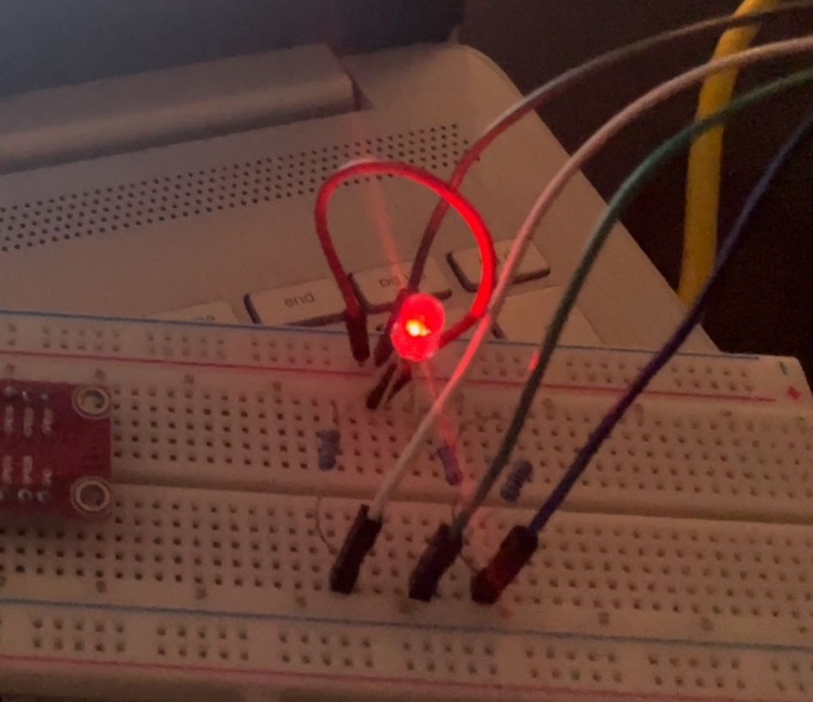

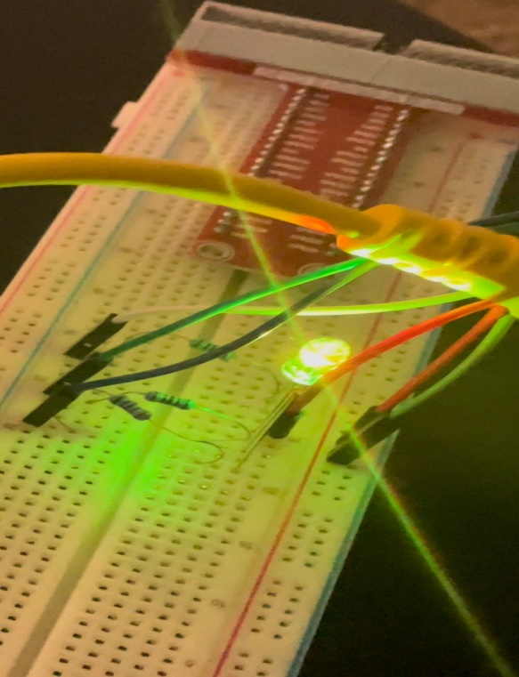

## 2.0 Hardware connections

Use the bread board and make connections as shown in visual representation below :

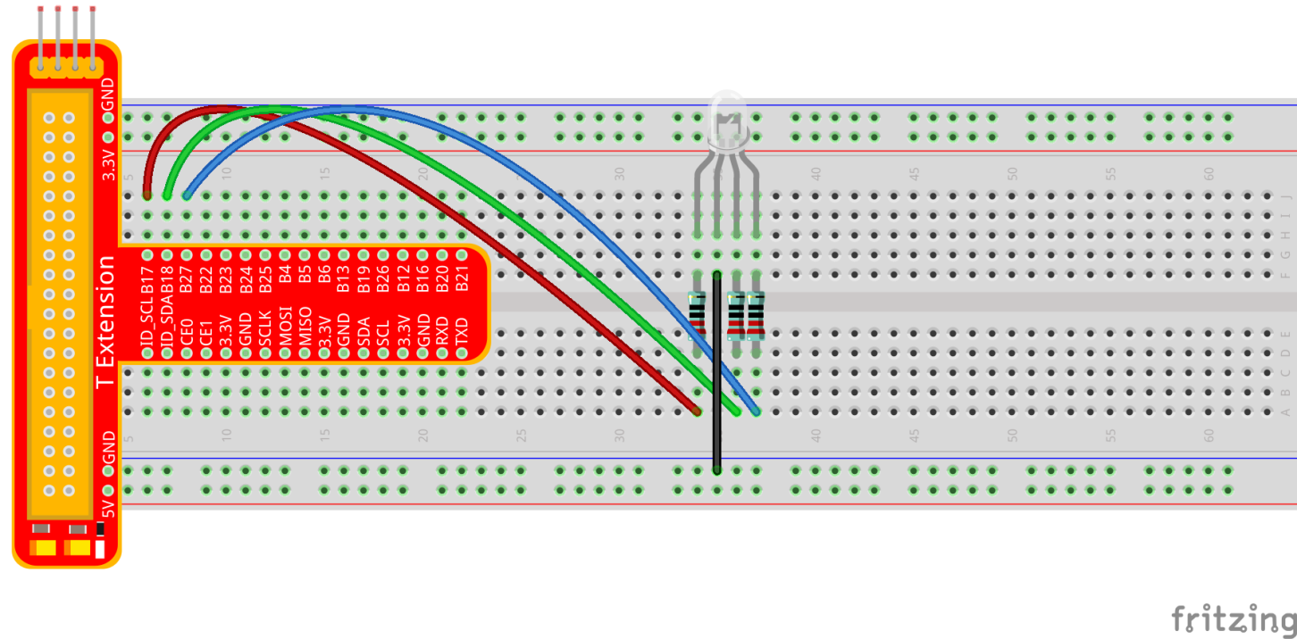

## Working

1. 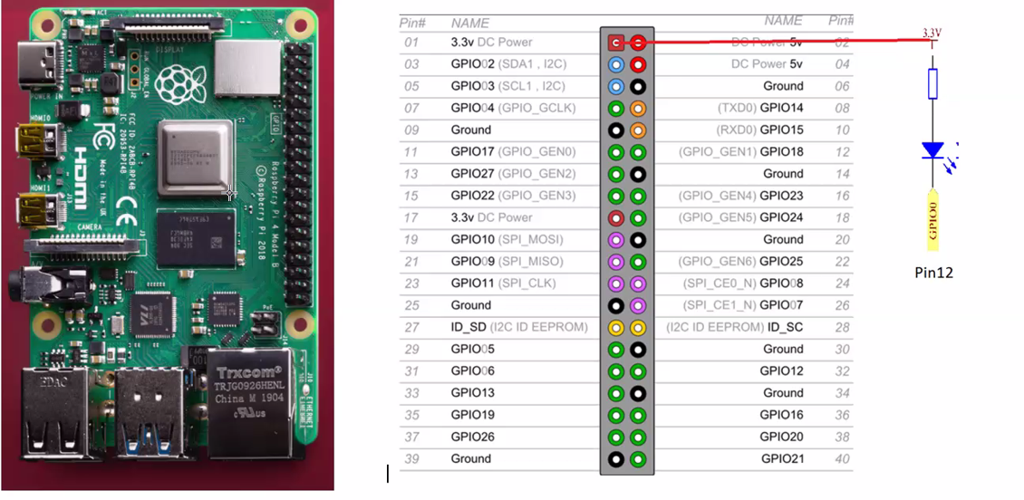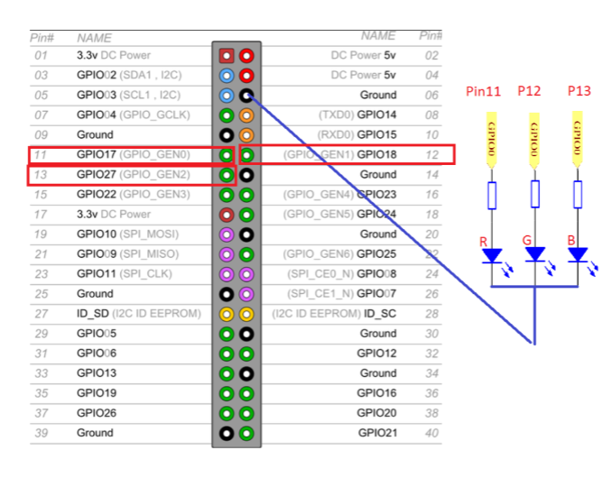Once the wireless connection is established then open thonny Python IDE which mostly is pre installed in raspberry Pi’s.
2. Make sure the Python library is uploaded and running .
3. Type in the program, and check for any errors.
4. Run the program
5. Check for RGB .

|  |  |
| --- | --- |
| **3.1** | **Programming**  Enter the following program on Thonny Python IDE : |

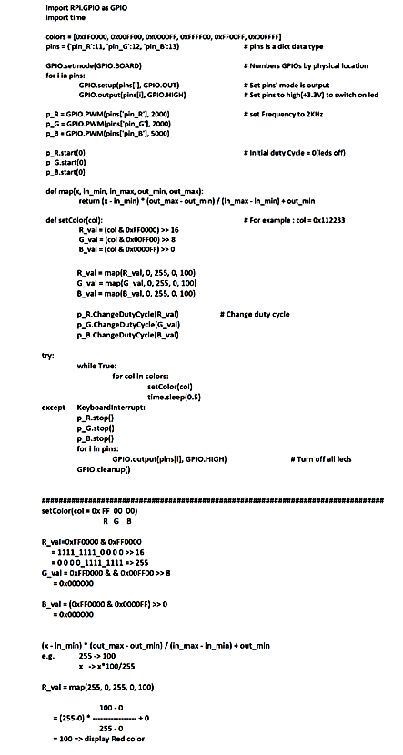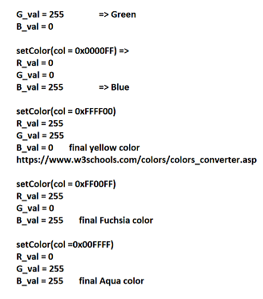 Contd…